  - State of the Health Workforce in the WHO African Region: A Decade Review of Progress and Emerging Priorities for Investments
Alignment. Investment. Sustainability

Popular version
Contents
1. Introduction 2
2. The Report Development Process 2
3. Health workforce profile – A ten year trend 2
4. Health Workforce Growth Enablers 3
5. Health Workforce need gaps 3
6. Impacts of health workforce density 3
7. Conclusions and recommendations 3

Introduction

The status of the health workforce is given in terms of stock and density, training and Education capacities, migration, employment status, supply, demand, and need for health workers, budgeting and spending, governance and leadership, impacts of the health workforce levels, and an analysis of key performance indicators compared to targets.

The Report Development Process
Data: Data were systematically combined from multiple sources, spanning the period between 2012 and 2022, including the National Health Workforce Account (NHWA – the 2023 release), Health Labour Market Analysis (HLMA), Country HRH profiles, HRH Strategic Plans and Annual Reports of Professional Regulatory Councils.
Selection of data points: Data were collected at the beginning of the decade (2013 or the nearest), mid-point (2018 or the latest) and at the end (2022 or the latest data available).
Adjustment: The data for 2022 were adjusted for private sector contribution with reference to the 2018 survey data point.

Health workforce profile – A ten-year trend

Data availability: Health workforce data availability and use have improved dramatically: Data availability and reporting improved tremendously between 2013 and 2022. With only data for 26% of the occupations reported across all countries in 2013, this improved to 75% in 2018 and 81% in 2022.
Data availability in the region for the years 2013, 2018 and 2022
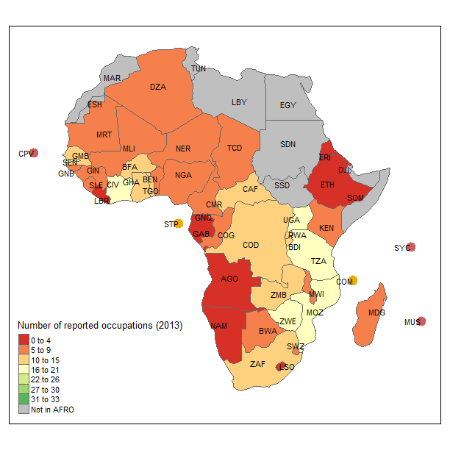 | 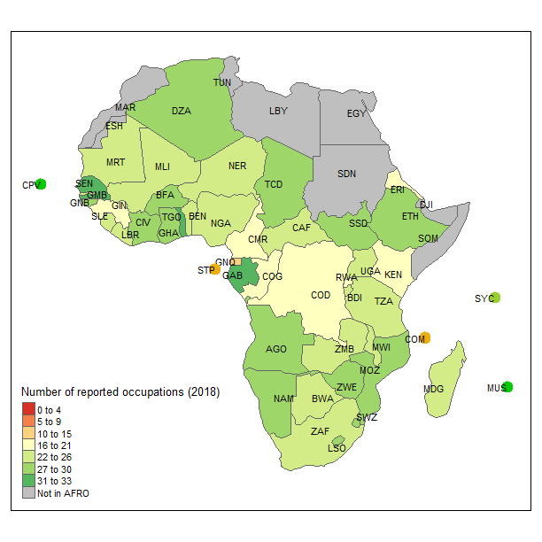 | 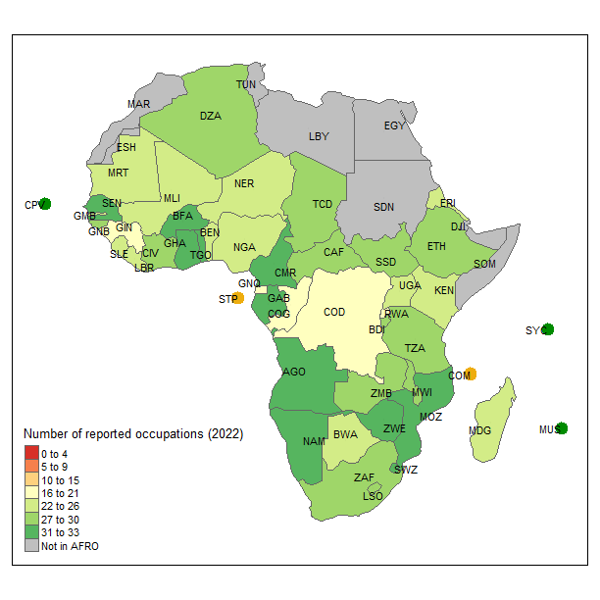

The overall stock and density of health workers are improving, but there are wide variations among countries and regional economic communities: The health workforce in the African Region has witnessed remarkable growth over the last decade. In 2022, the region had 5.1 million health workers of any kind, compared to 4.3 million in 2018 and only 1.6 million in 2013. This three-fold increase in the health workforce stock is due to a combination of improved data availability sharing reporting and the health workforce development efforts by countries.
In 2022, there were 27 doctors, nurses, midwives, dentists and pharmacists per 10,000 population in the region. The upper 25% of the countries or the upper quartile (made up of 12 countries) with the better densities have an average of 67.19 doctors, nurses, midwives, dentists and pharmacists per 10,000 population compared to a density of 5.57 for countries in the lower quartile (also made up of 12 countries).
The highest improvements in the density per 10,000 for doctors, nurses, midwives, dentists and pharmacists (SDG 3c tracer occupations) were witnessed in the UMMA (from 7.93 to 34.48), SADC (from 17.24 to 47.01), and COMESA (from 16.01 to 38.79) economic communities, with the least being in EAC (from 8.27 to 14.53).
There were 2.6 million doctors, nurses, midwives, dentists, and pharmacists in the African region, a threefold increase over the ten years and an annual growth rate of 13%. Of these, one in two was in lower-middle-income countries, one in three in low-income countries, and one in five in high/upper-middle-income countries.
Population growth is outpacing the growth in the stock of health workers: While 79% of the countries showed a positive trajectory in increasing their stock between 2018 and 2022, the workforce density per 10,000 population increased in 62% of the countries. The difference between the growth of stock and density was attributable to the population growing faster than the workforce development rate and marginally due to out-migration. Eight countries, or 17% of the region (Botswana, Burundi, DRC, Malawi, Mali, Niger, Rwanda and Senegal) increased their stock, but the population growth outpaced it. For 21% of the countries, the stock of health workers and the density reduced between 2018 and 2022. These are Central Africa Republic, Chad, Eritrea, Gabon, The Gambia, Guinea, Lesotho, Liberia, Madagascar and Mauritius.

Health Workforce Growth Enablers

Production (training)
Determinants of health workforce density
Investment
Planning and governance

Health Workforce need gaps
Unemployment
Migration
Need based projection

Impacts of health workforce density

Conclusions and recommendations

